Assignment Part - 3

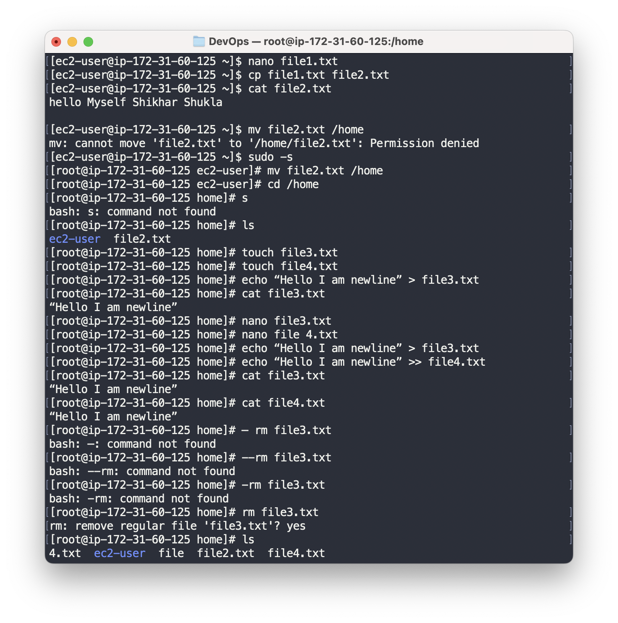

The difference between the two commands echo "Hello I am newline" > file3.txt and echo "Hello I am newline" >> file3.txt lies in the redirection operator > and >>.

The > operator is used to redirect the output of a command to a file and overwrite its contents. If the file file3.txt exists, its previous contents will be replaced with the output of the echo command.

The >> operator is used to append the output of a command to the end of a file. If the file file3.txt exists, the output of the echo command will be added to the end of its current contents.

So, in this case, the first command echo "Hello I am newline" > file3.txt will create a new file file3.txt if it does not already exist, or overwrite its contents if it does exist, with the output of the echo command.

The second command echo "Hello I am newline" >> file3.txt will create a new file file3.txt if it does not already exist, or append the output of the echo command to its end if it does exist.